

**Table of Contents**

* **Sign-Up, Sign-In, and Forgotten Passwords - 3**
  + Getting Started - 3
  + Sign-Up - 3
  + Sign-In  - 5
  + Forgotten Password - 6
* **User Settings - 8**
  + Updating User Passwords - 8
  + Updating User Profile Pictures - 8
* **Nest Page and Messaging - 9**
  + Private and Group Messaging - 9
    - Private Nest - 10
    - Group Nest - 12
      * Group Nests: Roles and Controls -12
        + Nest Buttons - 14
        + Message Buttons - 15
      * Inviting Users - 16
  + Sending Messages - 17
  + Notifications - 19
* **Administrative Features - 20**
  + Nest Page View - 20
  + Administrative Page - 22
    - Admin Dashboard View - 22
    - Nest Messaging Search View - 24
    - User Messaging Search View - 25
    - Messaging Statistics View - 26

**About Pigeon**

**The Team**

Pigeon was created in 2022 as a requirement for the CS 414 System Design Class a capstone project class for graduating Information Technology and Cyber Security Majors. The team is comprised of Caleb Knapp the project manager, Himprawa Khattri the quality assurance engineer, Timothy De Jesus the database administrator, and Mason Phillips the cyber security specialist. Each member worked as their role and contributed to the programming and system design as well.

**The Application**

The name for Pigeon came as an idea from the carrier pigeons used to deliver messages between two people. Just like the carrier pigeons could not be read as they flew through the air, our app Pigeon was meant to be a secure messaging service for users to communicate securely.

**Sign-Up, Sign-In, and Forgotten Passwords**

Getting Started

To visit Pigeon, use the web address http://csmain/cs414/cs414_team2/index.aspx to get to the “Index” page where the user will have the option to log in using their account credentials, sign up for a new account, or if they have forgotten their password, they may use the “Forgot Password” link button to regain access to their account.

Sign-Up

After selecting the “Sign Up” button the user will be taken to the sign-up page where they will be prompted to enter a username, email address, and password. Note that usernames may not include special characters or spaces and that usernames must be unique. Emails must also be unique and follow the format of emailname@students.pcci.edu or emailname@pcci.edu. The password must be entered twice to confirm it has been entered properly, it must be between 8 and 128 characters long and may not include the “|” pipe symbol. Once these are all entered, and any errors have been corrected the user will be able to select the “Sign Up” button and they will be sent to the email confirmation page. Note that users who have not confirmed their email will not be able to log in at this point but their account will have been created.

After completing the sign-up process, you will be immediately redirected to the email confirmation page where you will only need to enter the verification code to confirm your email and login.

Once the user has verified their account, they will be logged into the site and given access to the “Nest” page. Note that if a user exits the site and comes back to the “ConfirmEmail” page, they will need to enter their email address along with the verification code.

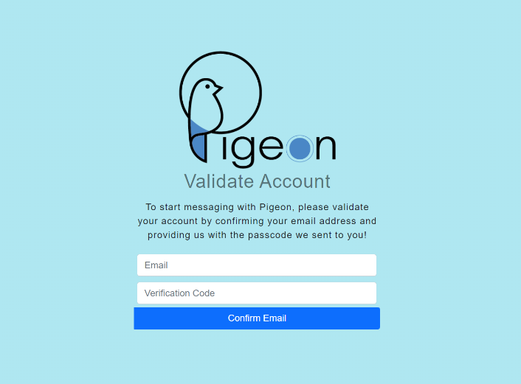

Sign-In

From the starting Pigeon page called “Index” the user will enter their username, password, and then select the “Sign In” button to login to their account.

Forgotten Password

If a user is having difficulty remembering their password, they can select the “Forgot Password” link text on the sign in page to reset their password. Note that a user is allowed five attempts to sign into their account before they will be locked out for fifteen minutes and may try again.

The user will need to use their email address and username selected at sign-up to begin this process. Once these fields are completed the user will need to select the “Send Code” button. If they enter a valid email and username combination the passcode to reset their password will be sent to the email used on sign-up. Note that the “Return to Login” button will be available for the user to allow them to return to the login page.

Once you have received your code, enter your new desired password, re-enter the desired password again to confirm nothing was mis-typed, and enter the passcode received via email. To finalize this information and login the user must select the “Submit Change” button. Note that if the user leaves the site between getting this confirmation code, they will need to resend the code again.

**User Settings**

The user settings page is in the top right drop-down menu by the user’s profile picture on the Nest page. This page allows the user to change their password and change their profile picture to one of the predetermined Pigeon images. This page also shows the user’s Pigeon Points, which are a cool way of tracking how active you are. Note you get 3 Pigeon Points per message sent.

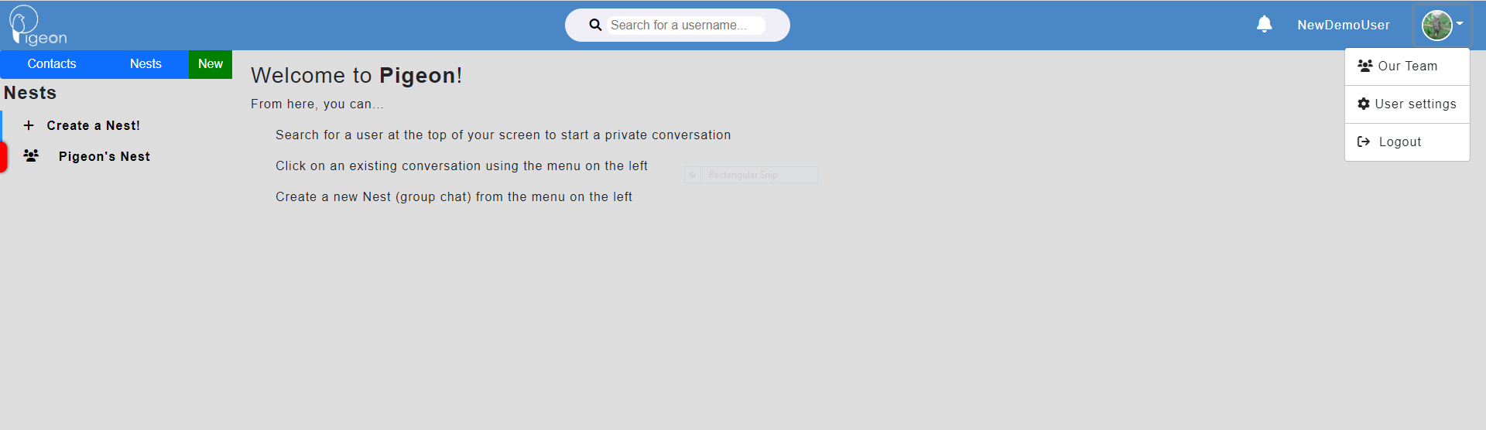

Updating User Passwords

To update a user’s password, they must use the update password box on the user settings page. They will enter their current password, their new desired password, and their desired password again to confirm that what they typed in was correct.

 Updating User Profile Pictures

To update a user’s profile picture, the user will simply click on their desired image, and the picture will be automatically updated. The picture above their name in the top left will show this change.

**Nest Page and Messaging**

Private and Group Messaging

From user registration, a new user will be greeted by the Nest page. This will be the page where all private and group messaging will be located. In Pigeon, we call these messaging groups Nests.

Private Nest

**Private Messaging** – Located under the “Contacts” tab, this will be where all direct messages will be located. To populate the contacts tab, the user will use the search bar located in the top middle of the nest page and enter the name of the user they wish to message.

Users may search either partial usernames or the whole username to find the user they wish to message. Once the user hits enter on the search, a box will populate with all matching usernames. Simply select one user to open a private messaging Nest between the users.

The private messaging will show the name of the user you are messaging in the contacts tab and in the top right above the usernames once the private messaging has been selected from the contacts tab.

Private Nests have most of the functionality of a group Nest, but users cannot be added to this type of messaging group, users cannot be kicked, and no local admin can be created in this group chat. A user can report a message, delete their own messages or mute the conversation in private Nests.

Group Nest

**Group Messaging** – Located under the “Nests” tab, this will be where all group messages are located. To populate the group Nests, a user can either accept a group invitation they have been sent or they may create a new Nest of their own. To begin this process, click the “+ Create a Nest!” button under the Nests tab.

After clicking “Create a Nest!”, the user can enter a name for their Nest and click the “+ Create Nest” button to finalize their Nest creation and name selection. Note that user’s will only be able to create a total of five Nests. Once they have reached this limit, they will need to delete one of their previous Nests to create another. This limit does not apply to joining Nests.

Group Nests: Roles and Controls

**Nest Creators** – This user will be highlighted in a blue box with the title “Nest Creator” inside of the right Nest member list when inside of a group Nest. These users will have access to a variety of controls to manage their Nest. Including inviting users, promoting users to local admin, removing users, deleting the Nest, muting the Nest, and deleting user messages.

**Local Admins** – This user will be highlighted in a blue box with the title “Admin” inside of the right Nest member list when inside of a group Nest. Only nest creators and system admins can promote a user to local admin in a group Nest. These users will have access to a variety of controls to manage a Nest. Including inviting users, removing users, leaving the Nest, muting the Nest, and deleting user messages. Note that this role is different from a system admin.

**Default User Role** – These users will not be highlighted in the members list in a group Nest. This role is assigned to any normal user when they are invited to a group. They are only able to delete their own messages, flag other user messages, mute the Nest and leave the Nest.

User Role Icons

System admins are identified by this icon within a group Nest and do not appear as members in the members panel of the group.

Nest creators are identified by this icon within a group Nest.

 Local admins are identified by this icon within a group Nest.

 Default users are identified by no icon within a group Nest.

Nest Buttons

These buttons will be located above the members’ list panel to the right of any Nest. Some will be only available to certain user types and group Nests.

 Allows the creator, local admin, or system admin to invite a user to their Nest.

Allows the creator or system admin to promote a user to be a local admin.

 Allows the creator, local admin, or system admin to remove a user from their Nest.

 Allows the creator or system admin to delete the Nest.

 Allows the local admin or a default user to leave the Nest.

 Any user can mute any type of Nest.

 When the Nest is muted, the user will not be notified of any new activity.

Message Buttons

These buttons will appear on messages sent within a Nest.

 Any user can report any message. This will give a message one flag and will be sent to the admin dashboard to be reviewed. Once a message is flagged twice or if it has been flagged by an admin the message will not appear in the group or private message.

When a message has been flagged by a user the color will turn red for that user to show that they have reported it.

 When the message has been approved by a system admin the flag will be replaced by a green check mark and will no longer be available for reporting. At this point, the message has been deemed okay to remain on the site and will need to be deleted by an admin, the user that sent it, or a Nest creator to be removed. If a system admin deems the message inappropriate, that message will be removed from the private or group Nest permanently.

 A Nest creator and local admin can delete any user and local admin’s message, and any user can delete their own message.

Inviting Users

When the “Invite User” button is selected, the user will be brought to a search where partial or full usernames can be used to search, and all matching usernames will be displayed.



Clicking on a user in the list will send them an invitation to the group.

Sending Messages



Messages can be sent with only text or with a file attached. To attach a file, the user must select the “Attach a file” button and then the “Choose File” button to choose which file they would like to send from their file directory. Note that to send a file the user must include text in the text box to send with the file. Only permitted file types of the following may be sent: .txt, .pdf, .doc, .docx, .jpg, .png, .jpeg, .webp, and .jfif. All messages sent by default user roles will need to have files approved. The max file size limit is 1MB.

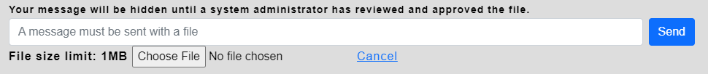

 Messages with a file have this icon attached to them and the file will be displayed once the message is decrypted.

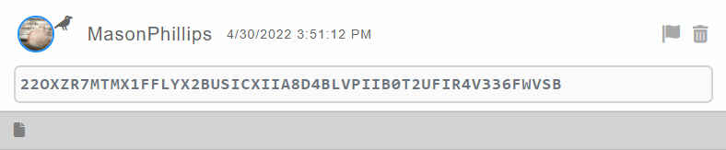

All messages will be obfuscated by cyphertext as a shoulder surfing protection. Once the cypher text box has been clicked the text will be displayed along with any files attached to that message. Once the “ClassWork.docx” link button has been selected the file will be downloaded in the user’s browser.

Messages with images attached can be downloaded but will also be displayed in the browser without downloading the image.

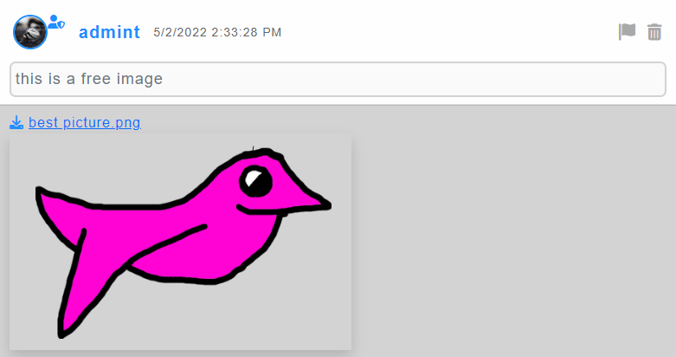

Notifications

When a user has a notification for either a Nest invite, a message being reported, or the outcome of a reported message, the bell icon at the top right of the nest icon will be colored red with an exclamation point.

No new notifications

 New unread notifications

Clicking the notification bell will display all notifications and clear the red coloring from the bell.

In the notification page, users can see their group invitations and users can either accept or reject these invitations.

Below “Group Invitations”, is “Other Notifications” which details the users’ flagged messages either their own or somebody that the user reported.

When a user has activity in a private or group Nest the “New” tab will appear in the top left of the Nest page by the “Contacts” and “Nests” tabs. This tab combines all the users new chats together in one panel.



**Administrative Features**

Nest Page View

On the Nest page there are two different admin types.

**Local Group Admins** – This admin type can be assigned to any user by either a Nest creator or a system admin and will be highlighted blue with an admin tag inside of a Nest. The local admins can use administrative features within a Nest which are: kicking users, inviting users and deleting messages.

**System Admins** – This admin type has full access to the administrative suite within a Nest, which includes: adding new users, removing users, locking Nests, deleting Nests, deleting messages, and promoting users to local admin. This admin does not appear in any Nest as a user and is included in every Nest that is created. System admins are also hidden in private messages as well, but these chats will not show up for system admins in their Nests on the Nest page. Graphical user interface, text, application, email

 Used to add users to a Nest as an admin.

 Used to delete a Nest as an admin.

 Used to unlock and lock Nest as an admin.

 Used to delete messages in a Nest as an admin.

 Used to kick users from a Nest as an admin.

 Used to promote users in a Nest as an admin or Nest creator.

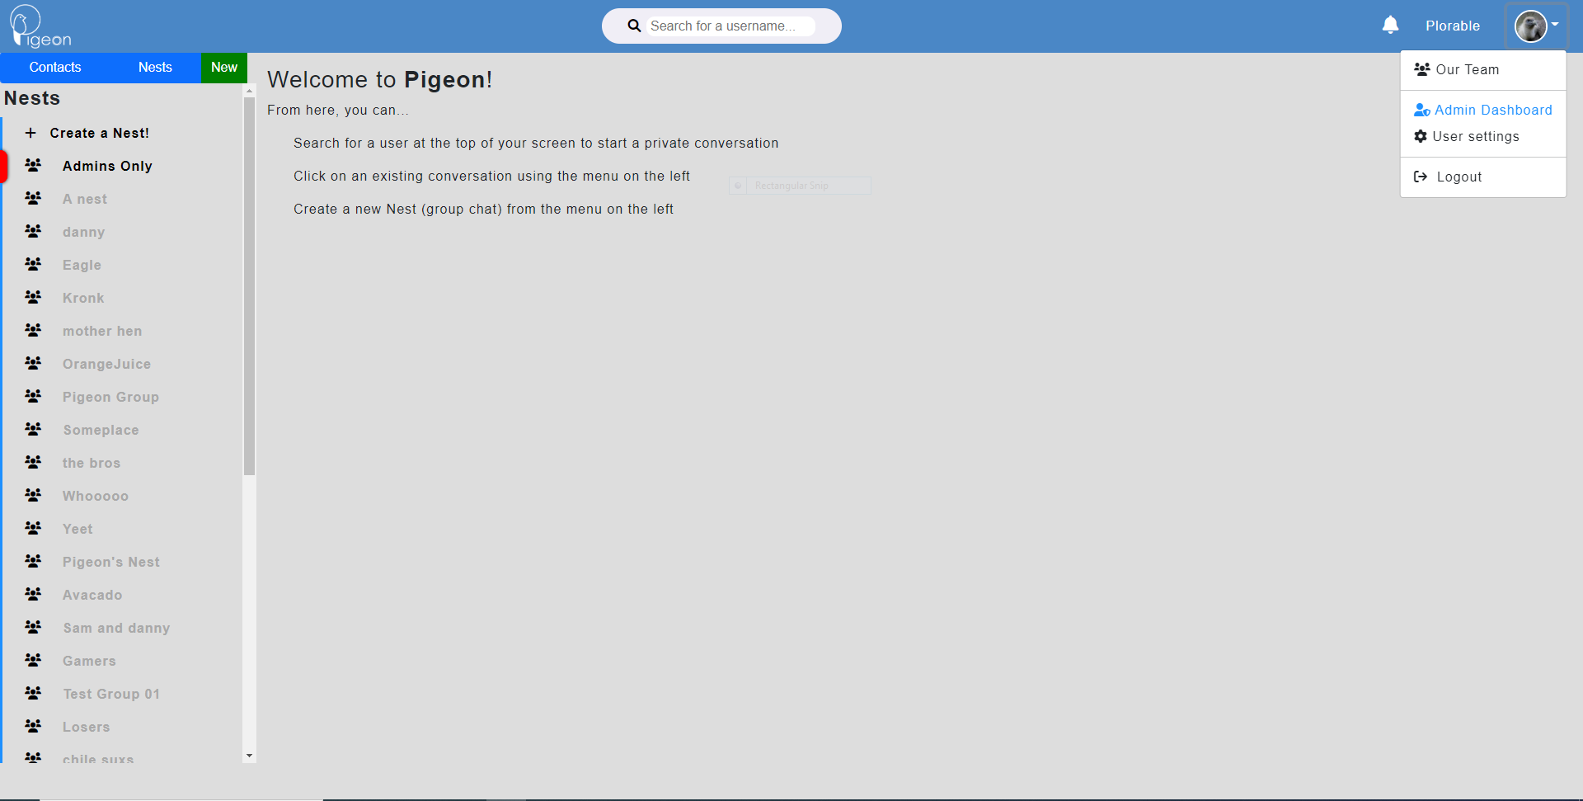

**Administrative Page**

From the Nest page, access to the admin dashboard is available through the user account drop-down in the top right of the page. Using the Admin Dashboard button, you will be taken to the administrative page dashboard. The admin page view can be changed by using the banner at the top of the page. Note that this page is only available to logged in system administrators.



**Admin Dashboard** – contains all users and all flagged messages pending review.

**Nest Messaging Search** – allows admins to search for a specific Nest to view messages and members in that Nest.

**User Messaging Search** – allows admins to search for a user and view all messages they have sent, and which Nests they are a part of.

**Messaging Statistics** – allows admins to run statistics on different time periods to get message counts and activity.

**Nests** – Allows admins to quickly navigate back to the main Nest page of the site.

Admin Dashboard View

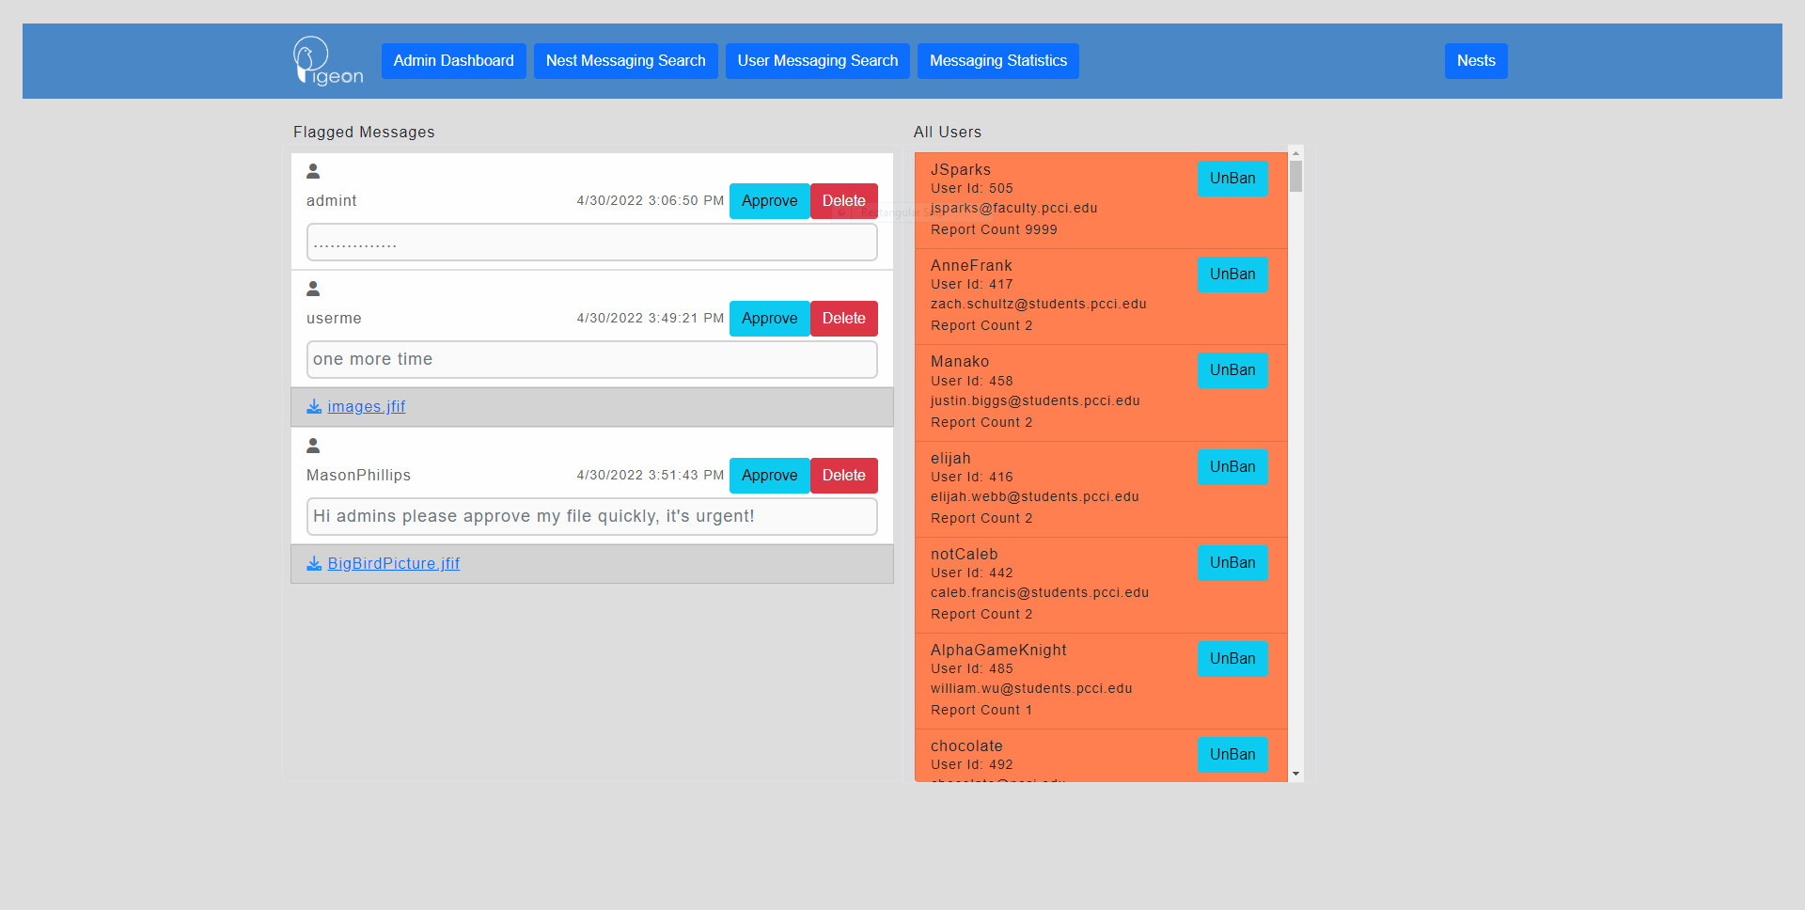

From the admin dashboard, system admins will be able to approve or delete user flagged messages. All users will also be viewable on this page. A system admin can look through users sorted by their report count and ban status to ban or unban them. This will also include basic information to use to further research the users accounts including usernames, id numbers and email addresses.

Users that have been banned are highlighted in a red orange box with a blue unban button.

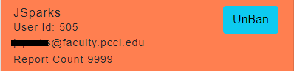

Users that have not been banned are not highlighted and have a red ban button.

Flagged messages that come up in the flagged messages column will not be obfuscated and will include any download files as well as the message text. All messages sent by default user accounts with files attached will be flagged to be reviewed on the admin dashboard.

Nest Messaging Search View

The Nest messaging search page view will allow admins to search for a Nest by id or by name to view the messages in that Nest and its users.

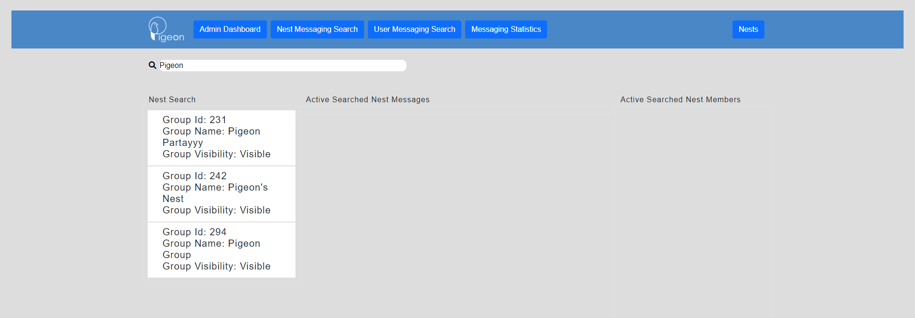

Once a name or id has been searched all matching Nest ids will displayed in the “Nest Search” column. This column displays the Nest name, id, and whether that Nest is deleted or visible. One of these Nests can be selected, and the “Active Searched Nest Messages” will populate with the messages in the selected Nest and the “Active Searched Nest Members” will populate with the members in the selected Nest with their user roles and id number.

Admins will also be able to delete messages in the Messages column and ban or unban users in the Members column. Note that messages without a delete button have already been deleted and will show up in this search despite not appearing on the Nest view on the main Nest page.

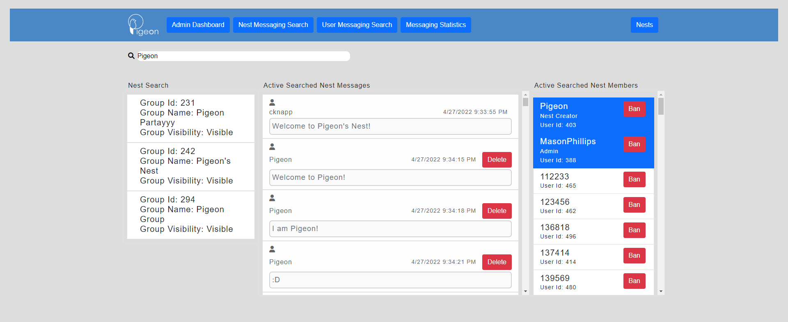

User Messaging Search View

The user messaging search page view will allow admins to search for a user by name. This allows admins to view all the messages they have sent, and which Nests they are members of.

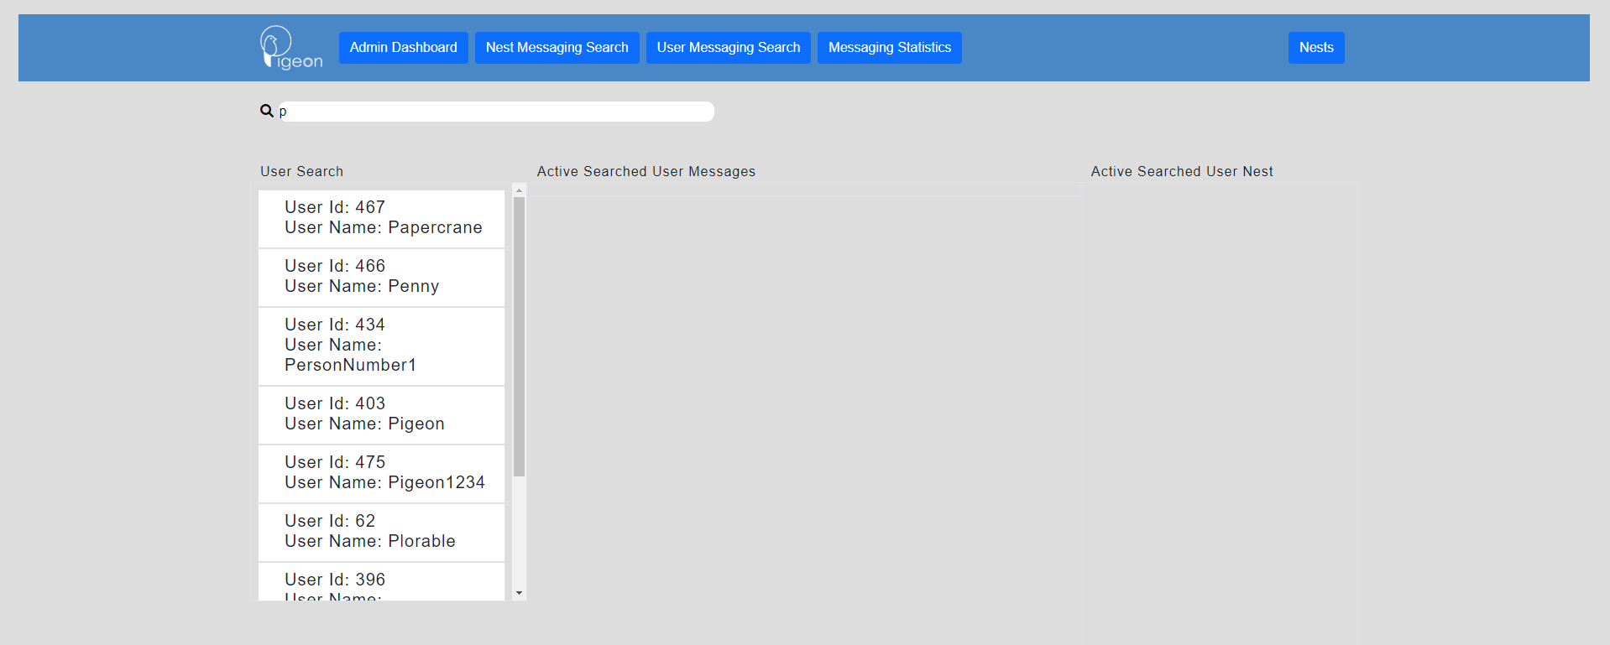

Once a name has been searched all matching usernames will be displayed in the “User Search” column. This column displays the usernames and ids. One of these users can be selected and the “Active Searched User Messages” will populate with the messages the selected user has sent since account creation and the “Active Searched User Nests” will populate with the user’s Nest that they are a member of with their names and id number.

The message column will display the Nest name where the message was sent, the Nest id, and the date that the message was sent. Admins will also be able to delete messages in the Messages column. Note that messages without a delete button have already been deleted and will show up in this search despite not appearing on the nest view on the main nest page.

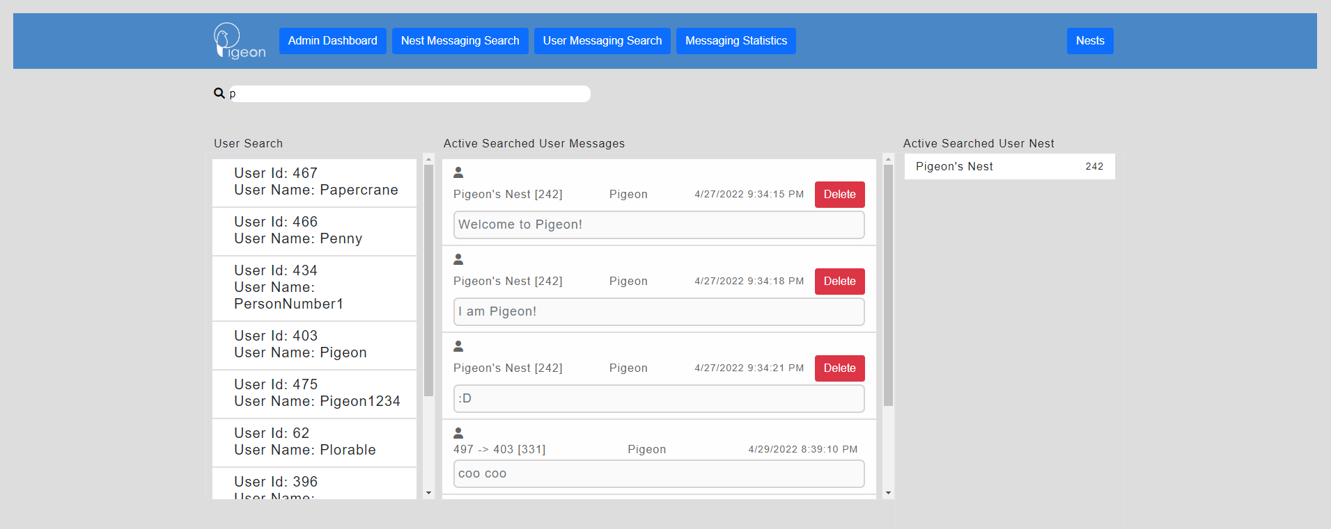

Messaging Statistics View

This statistics page of the admin page will allow admins to quickly view message counts in a time frame, most active user with message count in a time frame, most active Nest with message count in a time frame, message count in a time frame for a specific user, and message count for a specific Nest in a time frame.

To view the statistics choose a start date and time and an end date and time. Click “Find” to view the result. You can clear the selected date and time by clicking “Reset” button, while keeping the results.

Use the blank date and time slots to select a date or time, and use the space after the clock to enter a user id or group id for those two specified searches.

Note that leaving both the start and end date blank will set the start date to the last 24 hours and that entering a start date but no end date will set the end date to the current time. Time does not need to be entered but a date does need to be entered with time if it is specified. Leaving the start date blank always assumes you want the last 24 hours regardless of entering an end date.

